



TechnoReady In-Mexico

Challenge 8 – Testing Procedures for Operational Issues

Johan Alejandro Gloria González
Iván Kaleb Ramírez Torres

Nao ID: 3346 & 3357

November 18th, 2025

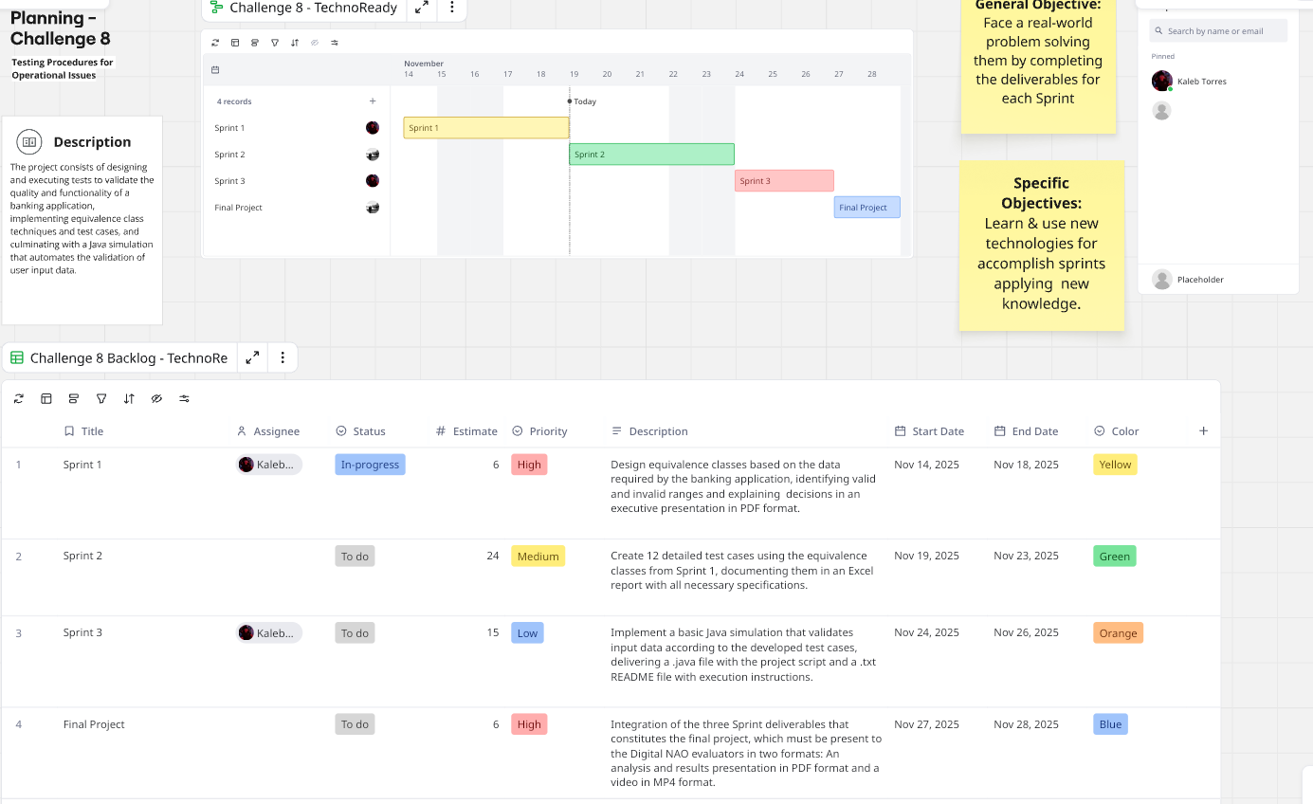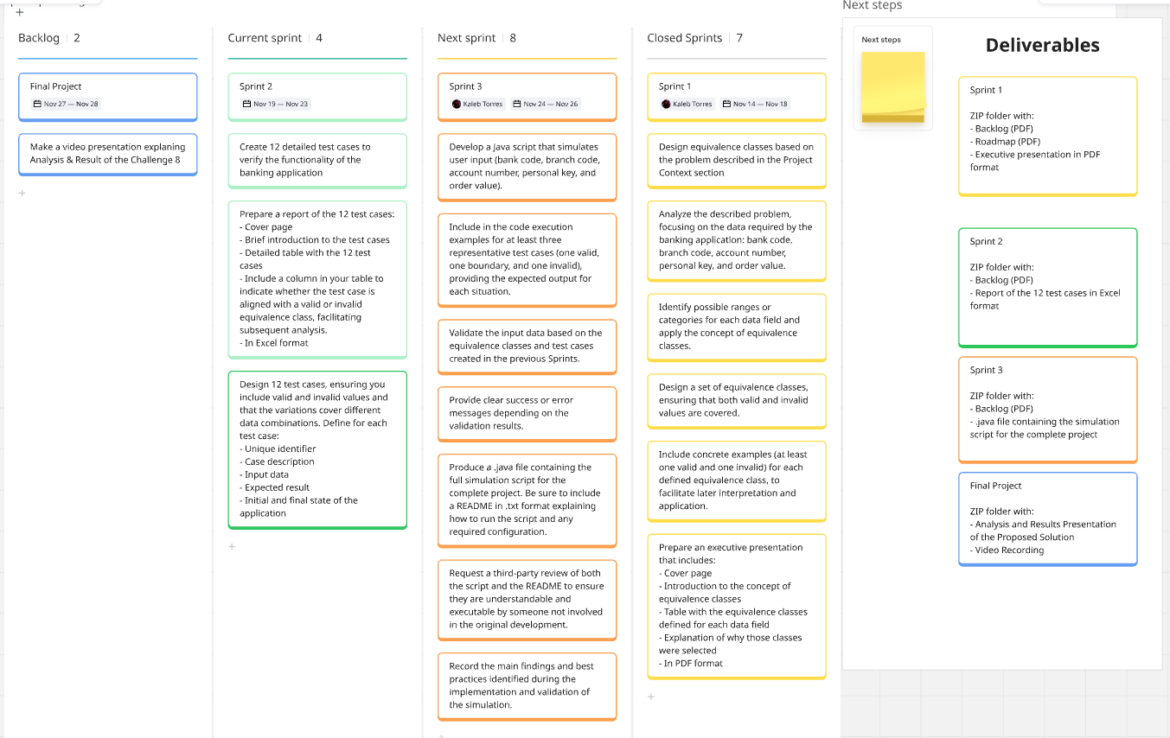

Para una mejor visualización, visitar:
https://miro.com/app/board/uXjVJpPHXtY=/
https://miro.com/app/board/uXjVJpPHXtY=/?share_link_id=12193599953

